**Experiment - 1.3(d)**

**Student Name: Milan Sharma UID: 23MAI10003**

**Branch: ME – CSE - AIML Section/Group: MAI – 1 (A)**

**Semester: 1st Date of Performance: 29 Aug 2023**

**Subject Name: Python Programming Subject Code: 23 CSH 623**

1. **Aim of the Experiment :**

Write a python program to check whether the given number is palindrome or not.

1. **Objective of the Experiment :**

To check whether the given number is palindrome or not.

1. **Algorithm/ Steps for Experiment :**

1. Take the value of the integer and store in a variable.

2. Transfer the value of the integer into another temporary variable.

3. Using a while loop, get each digit of the number and store the reversed number in another variable.

4. Check if the reverse of the number is equal to the one in the temporary variable.

5. Print the final result.

6. Exit.

1. **Code for Experiment :**

number = int(input("Please Enter any Number: "))

reverse = 0

temp = number

while(temp > 0):

Reminder = temp % 10

reverse = (reverse * 10) + Reminder

temp = temp //10

print("Reverse of a Given number is = %d" %reverse)

if(number == reverse):

print("%d is a Palindrome Number" %number)

else:

print("%d is not a Palindrome Number" %number)

1. **Result/Output :**

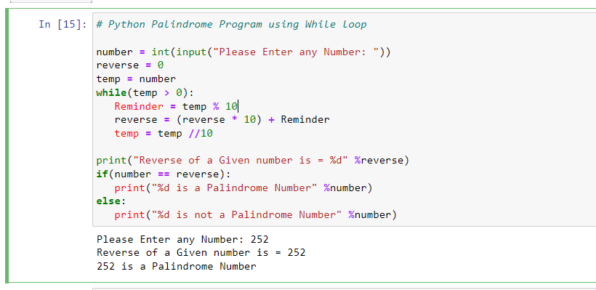

1. **Learning outcomes (What I have learnt):**
2. Learnt what is Palindrome

**Evaluation Grid (To be created as per the SOP and Assessment guidelines by the faculty):**

|  |  |  |  |
| --- | --- | --- | --- |
| **Sr. No.** | **Parameters** | **Maximum Marks** | **Marks Obtained** |
| **1.** | **Student Performance**  **(Conduct of experiment)**  **Objectives/Outcomes.** | 12 |  |
| **2.** | **Viva Voce** | 10 |  |
| **3.** | **Submission of Work Sheet**  **(Record)** | 8 |  |